Freshford Parish Council
14 July 2025
Dark Lane Proposal
Introduction
Two residents from Dark Lane attended the May PC meeting, outlining the series in incidents in Dark Lane/The Hill with delivery drivers damaging properties and boundary walls. Some residents have experienced multiple incidents in one calendar year.
The options considered to address the address are:
- Close Dark Lane at the junction with New Road
- Downgrade Dark Lane to a Bridleway.
- Introduce a Low Traffic Neighbourhood
- Improved signage.
Evaluation of Options
- This is the simplest, cheapest proposal to address the problem. The issue has always been how traffic will turn around once in the Church Hill/Dark Lane set of streets.
- Whilst in 2008 a BANES Engineer did suggest this as an option, it is not supported by the current Highways Engineer, so is a non-starter.
- My preference would be an LTN. I will continue to press for this via the Ward Councillor. My understanding is that the main focus for BANES is on urban areas. It is on the list, but other schemes will always have a higher priority. This would be the most radical and expensive solution. A formal consultation and pilot scheme would be required and likely to meet some opposition.
- Modern drivers largely ignore signage and blindly follow their SatNavs. Whilst this might seem a simple solution, it is, in my opinion, pointless and ineffective.
The proposal is outlined below, based on a site visit with the BANES Highway Engineer. I am confident of BANES support for a TRO.
I would like your support for a local informal consultation of all the residents of Dark Lane and Church Hill to gauge support for the proposal.

Proposal from Freshford PC and BANES Highways
A removable bollard at this location. PC will have a key. Can be used by residents when work is required to their walls or property.
New paving across the entrance to Dark Lane + set of fixed bollards + NO Entry sign. Still unusable by pedestrians’ cyclists & wheelchairs

M

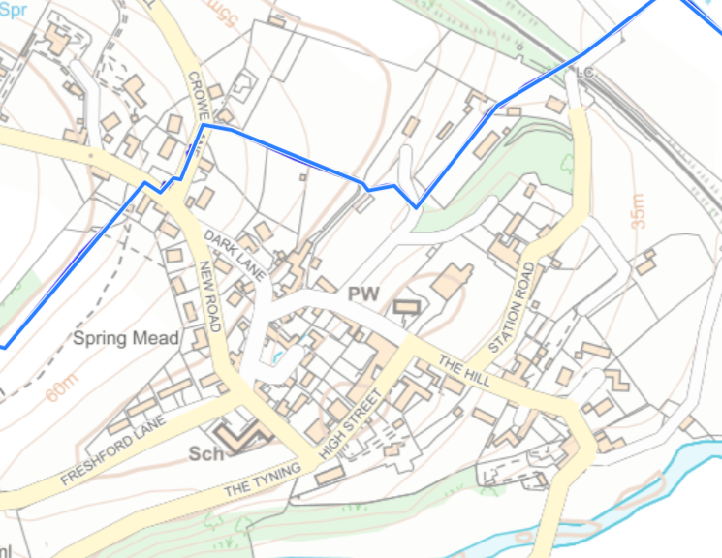
Summary
- No entry sign at the Dark Lane junction with New Road.
- Fixed bollards at the Dark Lane junction with New Road.
- New paving across the entrance to Dark Lane at the junction with New Road.
- Temporary, movable bollard at the other end of Dark Lane, for which PC residents can remove when required for residents to allow trades vehicles access.
- Dark Lane will be formally removed as a route on Google Maps in due course. We will collaborate with BANES to facilitate a prompt resolution of this matter.
Please let me have your comments.
Julian Carpenter
4 July 2025.

