Freshford Parish Council.

Meeting on the 10th June 2019, Memorial Hall, Freshford.

Report to Councillors - Road Traffic Update

Bus stop seat, Freshford Lane.

Received from B&NES, Public Transport Officer.

From a Public Transport point of view we are ok with moving the bus stop near the Hall as Stefan has approved it on Traffic and Safety grounds, likewise we are more than happy leaving the bus stop in its current location so the decision would be the parish council’s if you want to progress this further. Unfortunately we have conducted a review of our capital programme for this financial year and unfortunately we are unable to provide any contribution towards the funding for this scheme.

If you do take this forward, and decide to move the stop to the Hall, Stefan has said that a patch of hardstanding would be needed at the location near the Hall for passengers to wait so they do not have to wait on the grass, this would be an additional cost for you to consider.

Regards

Jon

Jonathan King
Public Transport Officer
Bath & North East Somerset Council
Tel: 01225 394287
Fax: 01225 394335
Email: jon_king@bathnes.gov.uk

Comment

I think it likely that Maryann Cohen will wish to pursue this now through an Application to FLiSCA. Though it has taken far longer than I would have wished I believe that the fullest information can now be put before the FLiSCA Trustees - if she goes down that route.

1. The verge is in the ownership of B&NES Council.

2. The Authority has no objection to a seat being installed on the verge.

3. The cost is dependent on what seat is chosen. A concrete plinth needs also to be constructed. Likely costs in the region of £1000.

4. The PC has yet to determine whether or not it is (a) prepared to view any seat installed as a Fixed Village Asset (b) prepared to take responsibility for its long term care or maintenance. At the moment the verge has not been cut and is unusable.

In the Alternative.

1. The Authority would not object to the bus stop being moved to closer to the Memorial Hall entrance. As a matter of fact it is not uncommon for the bus to stop at at this point as it is closer to the Shop and the Hall and to the path up to the Glebe houses

2. They have no concerns on Traffic and Safety grounds.

3. People catching the bus could use the existing seat - it is on the other side of the road but travellers could see the bus approaching.

4. On return journeys from Bath the bus already tends to pull in at the Hall car park entrance.

5. The PC would need to carry out some remedial work to the ground in front of the seat - some hardstanding.

6. The costs of 5 above not yet determined but I would think that any work can be carried out at a fraction of the cost of installing a new seat.

For discussion by the PC

Is the PC prepared to support any Grant application to FliSCA for the installation of a new seat?

Is the PC prepared to accept both ownership and the long term responsibility for the maintenance of any seat?

Is the PC prepared to accept responsibility for the additional maintenance of the verge at that point so that it is maintained to an acceptable standard? ( Note: the new B&NES Council may review the existing policy decision to end the Street Sweeper Scheme. )

In the alternative, will the PC support move the bus stop to a point closer to the Memorial Hall car park entrance and improve the verge by the existing seat?

In there alternative, should matters rest as they now exist - the bus stop where it is and no seat installed?

Rosemary Lane.

Residents have been expressing their continuing concerns about vehicles using Rosemary Lane. Signs at the Abbey lane junction indicate that the lane is unsuitable for HGVs and a further sign indicates that the road narrows. At the Freshford Mill end of the Lane there is weight restriction sign on the narrow bridge.

I have set out below recent correspondence from two Rosemary Lane residents - the first sent to Neil Butters (who then copied me in) and the second batch which were sent directly to me from Sharpstone resident Phil Affleck . I have set out the correspondence in full to assist councillors in their understanding of these long standing issues coupled with the difficulties in seeking to find solutions that will have an enduring and positive effect on traffic movements.

Councillors are asked to Note the concerns expressed and to be aware that enquiries are continuing particularly in relation to the Freshford Mill conditions

To Neil Butters

I am writing to you as my local councillor to raise awareness to a particular traffic problem that has arisen in Rosemary Lane, Freshford.
I have lived in my cottage on Rosemary Lane since 1972 and until the last year , without major incident. Now in less than 12 months a small retaining wall between my front door and the lane has been demolished 3 times by 3 different lorries heading for 3 different destinations in the village.
I have attached 2 photos of the latest incident on the 16th April. One of the damaged done and one of the offending vehicle.
There is advisory signage at the top of Rosemary Lane, both Highways Authority and Freshford Mill development but these are being ignored.
I would appreciate your thoughts on what can be done to discourage these lorries and the potential damage they can cause.
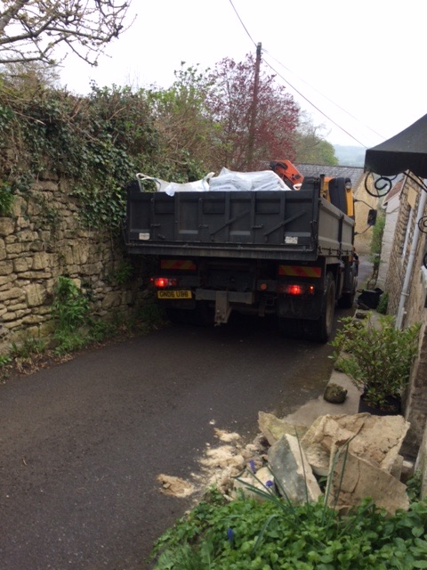

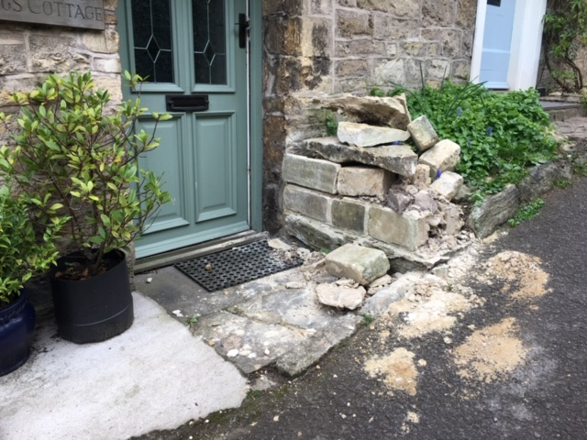

To Nick Stevens:

As you will know the Freshford Mill development has made good progress and has now brought several completed properties to market.
Having spoken to many of the residents of Rosemary Lane and Sharpstone there is obviously much concern about the impact on traffic in the lane. Although the access to the Mill was to have impeded access from the Sharpstone side of Rosemary Lane, the access layout has since been altered in such a way that entering and exiting up Rosemary Lane is now simple. The Postcode if entered into any satnav or Googe maps, will always direct you down Rosemary Lane. So this is the route that all the deliveries from the increasing online ordering we all now do, will come to get to the Mill. I think you’ll agree this a big concern and potentially dangerous.

With your Highways hat on, can we please meet up to discuss what options there may be to mitigate the impact on the lane.

Regards
Phil

Phil Affleck
Abbotsleigh Cottage, Rosemary Lane, Freshford, Bath BA2 7UD
Tel: 01225 722218 Mob: 07880 528852

Hi Phil -

Thanks for this.

I have made enquiries of the B&NES Planning Officer for Freshford Mill to first know the current status of the planning conditions attached to the development. He is going to check on these and then get back to me.

So far as I can tell, the two relevant conditions - the sweep access from the site and the reconfiguration of the Abbey Lane/Rosemary Lane junction have not been formally discharged and will not be discharged until B&NES Highways Department are satisfied that the work has been completed in accordance with the plans lodged.

There is an additional condition requiring the developers to publish for new residents a Welcome and Information Pack setting out useful information including access to public transport. The Parish Council always contemplated that the Pack would advise residents also to make clear to delivery drivers that access to the site was through the village and Crabtree Lane and not down Rosemary Lane.

On the Sat Nav point, it is an almost intractable problem over which it is impossible to exercise ultimate control. What I have done is to go to Google Maps and then input the unsuitability of Rosemary Lane as a through road due to its restricted width. This has lead to receiving an acknowledgement from The Google Maps Team saying that they will review the position and then be in touch. If Rosemary Lane residents all do the same then perhaps the message will get through and lead to change.

For the moment I would suggest that we first wait to hear back from the Planning Officer so that we know for certain the current status of the planning conditions attaching to the development. But in the interim by all means do let me have your thoughts on what options you would like to consider to help mitigate the potential for adverse impact on Rosemary Lane. If you could invent an App to rid the world of motorists blindly following their Sat Nav routes while ignoring clear signage and the evidence of their own eyes, that would be particularly useful!

Best wishes,

Nick.

Hi Nick,

Thanks for your response. I just know that what ever information is provided to the residents of the Mill, it’s simply not possible in many instances to give any directions advice and anyway they they probably won’t bother as it doesn’t directly affect them.
With the satnav issue, if we do succeed in getting Rosemary lane excluded on satnav for lorries, we would still have vans of all sizes coming that way and to be fair the residents in the lane obviously still need van deliveries so it’s a bit intractable.
Last month I sent out a note to all the residents in the lane, most have responded and all have indicated that they would want the lane blocked to vehicles at the bridge, with a turning space by the bridge. This is a proposal we have previously looked at when owner of the land by the bridge said he would be amenable to allowing a turning point partially over his land. I realise this will be considered a rather radical solution, but in the real world, nothing else will actually work!
We will see if the current configuration is accepted and discharged by BANES Highways, but even if they did demand changes to ensure the entrance to stop access/exit up Rosemary Lane, the deliveries will still come that way due their satnav.

Regards
Phil
—

When Neil Butters again raised the issue Of SatNav with B&NES Council last year this is the reply he received:

Dear Neil

I’m afraid we have very little influence over the routing options that sat navs provide and you’re right that this is likely to be an increasing problem now that more people have real-time traffic information allowing for automatic re-routes according to congestion. It’s an issue cropping up all over the country: https://www.standard.co.uk/news/transport/map-apps-like-waze-turning-quiet-london-streets-into-polluted-rat-runs-a3507646.html

Most sat nav companies now have mobile phone app versions of the in-car devices, and the public can report issues or inaccuracies via their web pages. It’s possible to do this for Google Maps, TomTom My Drive and Waze for example. But’s it’s completely at the discretion of these companies as to whether they remove roads as route options.

Regards

Paul

Paul Garrod
Traffic Management & Network Manager
Bath & North East Somerset Council
Telephone: 01225 394336
Mobile: 07968 622642
Email: paul_garrod@bathnes.gov.uk<mailto:paul_garrod@bathnes.gov.uk>
www.bathnes.gov.uk<http://www.bathnes.gov.uk/>
www.twitter.com/bathnes<http://www.twitter.com/bathnes>

————————————————————————————————————————

